Assignment 4: SQL SELECT Queries Assignment

- List all the records in the student table.
Ans: SELECT * FROM STUDENTS;
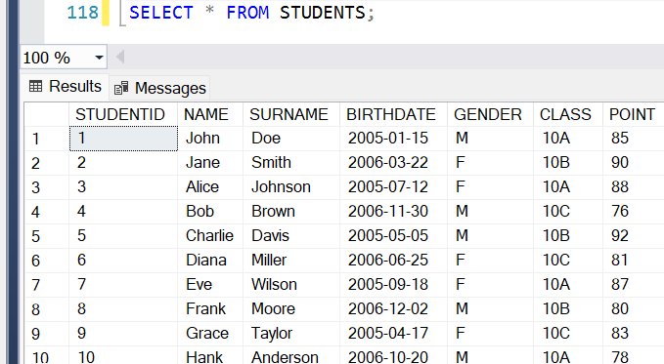

- List the name surname and class of the student in the student table
Ans: SELECT NAME, SURNAME, CLASS FROM STUDENTS;
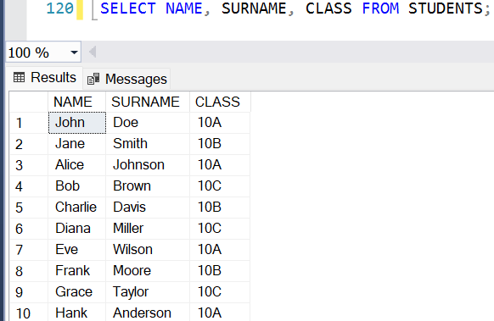

- List the gender Female (F) records in the student table
Ans: SELECT * FROM STUDENTS
WHERE GENDER = 'F';
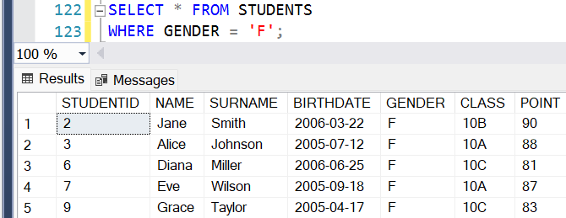

- List the names of each class in the way of being seen once in the student table
Ans: SELECT DISTINCT CLASS
FROM STUDENTS;
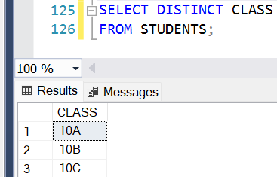

- List the students with Female gender and the class 10Math in the student table
Ans: SELECT * FROM STUDENTS
WHERE GENDER = 'F' AND CLASS = '10MATH';
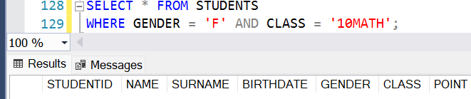

- List the names, surnames and classes of the students in the class 10Math or 10Sci in the student table
Ans: SELECT NAME, SURNAME, CLASS FROM STUDENTS
WHERE CLASS IN ('10MATH', '10SCI');
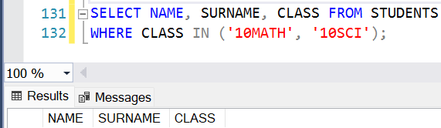

- List the students name surname and school number in the student table
Ans: SELECT NAME, SURNAME, STUDENTID AS SCHOOL_NUMBER
FROM STUDENTS;
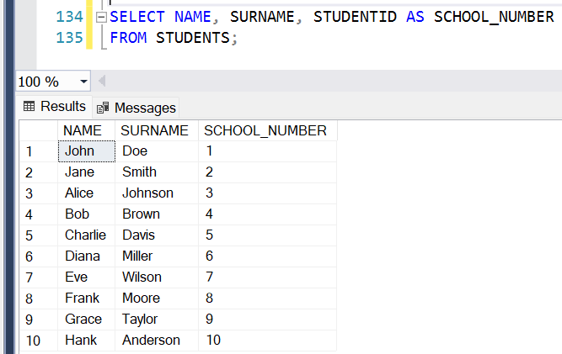

- List the students name and surname by combining them as name surname in the student table
Ans: SELECT CONCAT(NAME, ' ', SURNAME) AS [NAME SURNAME]
FROM STUDENTS;
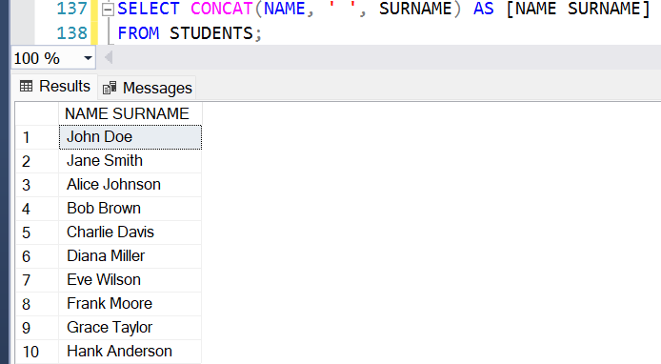

- List the students with the names starting with “A” letter in the student table
Ans: SELECT * FROM STUDENTS
WHERE NAME LIKE 'A%';
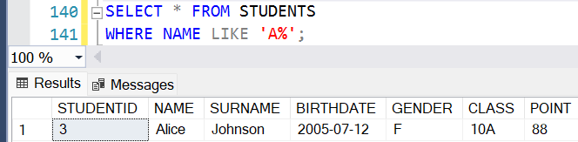

- List the book names and pages count with number of pages between 50 and 200 in the book table
Ans: SELECT NAME, PAGECOUNT
FROM BOOKS
WHERE PAGECOUNT BETWEEN 50 AND 200;
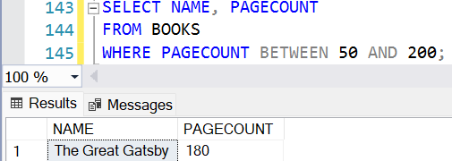

- List the students with names Emma Sophia and Robert in the student table
Ans: SELECT * FROM STUDENTS
WHERE NAME IN ('EMMA', 'SOPHIA', 'ROBERT');
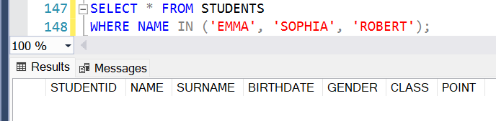

- List the students with names starting with A D and K in the student table
Ans: SELECT * FROM STUDENTS
WHERE NAME LIKE 'A%'
OR NAME LIKE 'D%'
OR NAME LIKE 'K%';
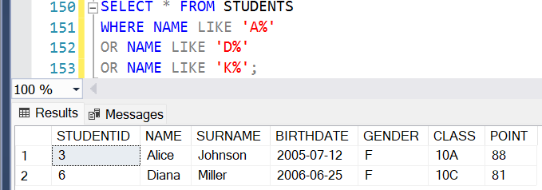

- List the names surnames classes and genders of males in 9Math or females in 9His in the student table
Ans: SELECT NAME, SURNAME, CLASS, GENDER
FROM STUDENTS
WHERE (GENDER = 'M' AND CLASS = '9MATH')
OR (GENDER = 'F' AND CLASS = '9HIS');
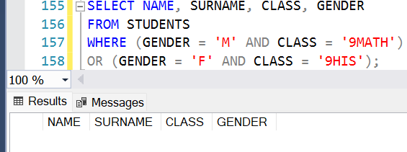

- List the males whose classes are 10Math or 10Bio
Ans: SELECT NAME, SURNAME, CLASS, GENDER
FROM STUDENTS
WHERE GENDER = 'M'
AND CLASS IN ('10MATH', '10BIO');
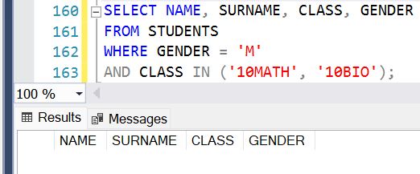

- List the students with birth year 1989 in the student table
Ans: SELECT * FROM STUDENTS
WHERE YEAR(BIRTHDATE) = 1989;
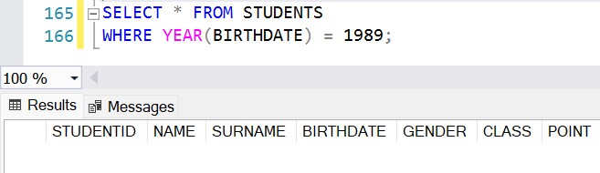

- List the female students with student numbers between 30 and 50
Ans: SELECT NAME, SURNAME, STUDENTID, CLASS, GENDER
FROM STUDENTS
WHERE GENDER = 'F'
AND STUDENTID BETWEEN 30 AND 50;

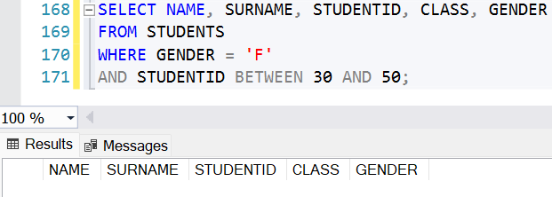

- List the students according to their names
Ans: SELECT * FROM STUDENTS
ORDER BY NAME;
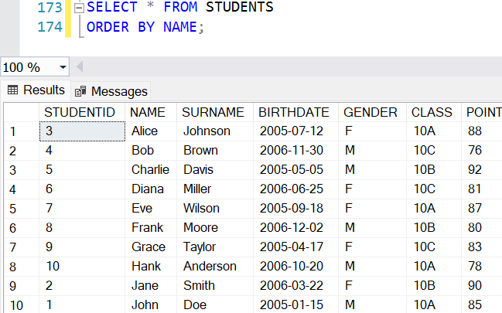

- List the students by names for those with same names. List them by their surnames
Ans: SELECT * FROM STUDENTS
ORDER BY NAME, SURNAME;
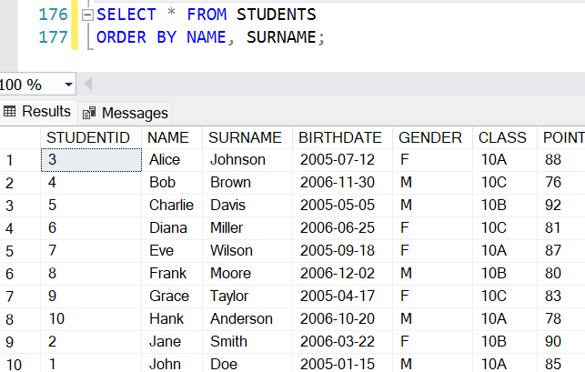

- List the students in 10Math by decreasing school numbers
Ans: SELECT STUDENTID, NAME, SURNAME, CLASS
FROM STUDENTS
WHERE CLASS = '10MATH'
ORDER BY STUDENTID DESC;
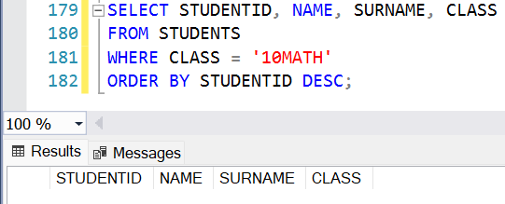

- List the first 10 records in the student chart
Ans: SELECT TOP 10 *
FROM STUDENTS;
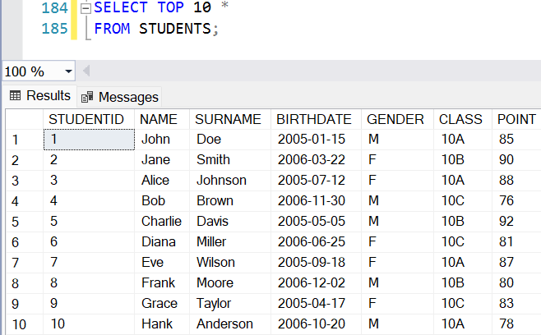

- List the first 10 records name surname and date of birth information in the student table
Ans: SELECT TOP 10 NAME, SURNAME, BIRTHDATE
FROM STUDENTS
ORDER BY STUDENTID ASC;
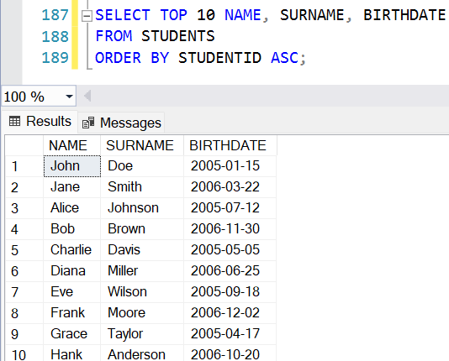

- List the book with the most page number
Ans: SELECT TOP 1 NAME, PAGECOUNT
FROM BOOKS
ORDER BY PAGECOUNT DESC;
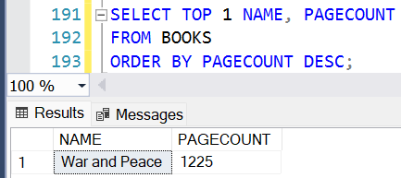

- List the youngest student in the student table
Ans: SELECT TOP 1 NAME, SURNAME, BIRTHDATE
FROM STUDENTS
ORDER BY BIRTHDATE DESC;
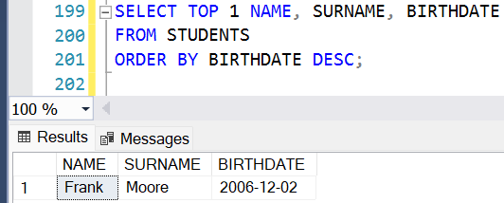

- List the oldest student in the 10Math class
Ans: SELECT TOP 1 NAME, SURNAME, CLASS, BIRTHDATE
FROM STUDENTS
WHERE CLASS = '10MATH'
ORDER BY BIRTHDATE ASC;
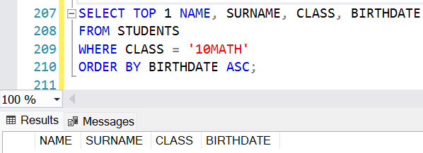

- List the books with the second letter N
Ans: SELECT BOOKID, NAME, PAGECOUNT
FROM BOOKS
WHERE NAME LIKE '_N%';
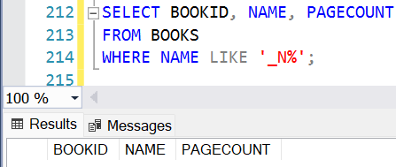

- List the students by grouping according to their classes
Ans: SELECT CLASS, COUNT (*) AS TOTAL_STUDENTS
FROM STUDENTS
GROUP BY CLASS;
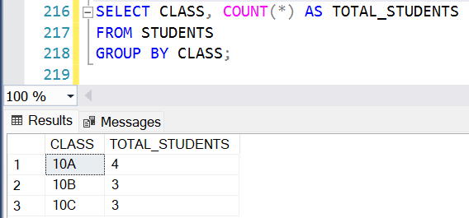

- List the students to be different in each questioning randomly
Ans: SELECT * FROM STUDENTS
ORDER BY NEWID();
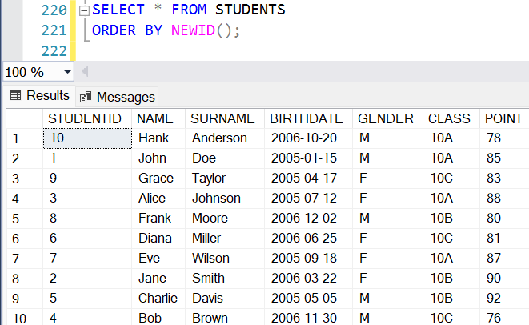

- Pick a random student from student table
Ans: SELECT TOP 1 * FROM STUDENTS
ORDER BY NEWID();
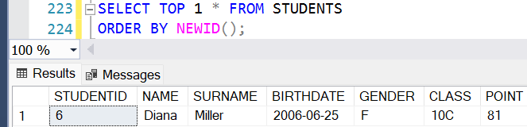

- Bring some random student’s name , surname and number from class 10Math
Ans: SELECT TOP 3 STUDENTID AS SCHOOL_NUMBER, NAME, SURNAME
FROM STUDENTS
WHERE CLASS = '10MATH'
ORDER BY NEWID();
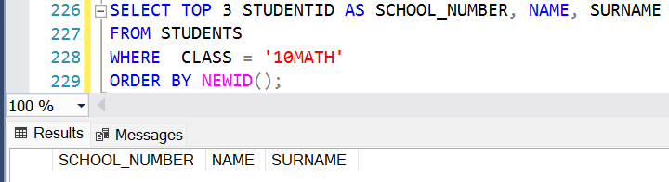

- Add the writer named Smith Allen to the authors table
Ans: INSERT INTO AUTHORS (AUTHORID, NAME, SURNAME)
VALUES (11, 'SMITH', 'ALLEN');
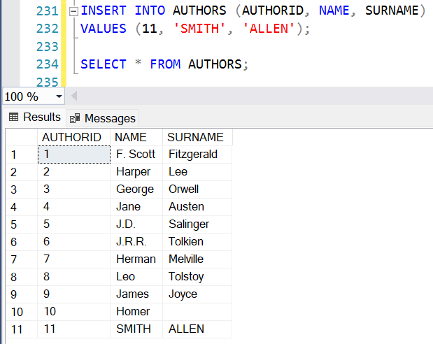

- Add the genre of biography to the genre table
Ans: INSERT INTO TYPES (TYPEID, NAME)
VALUES (11, 'Biography');
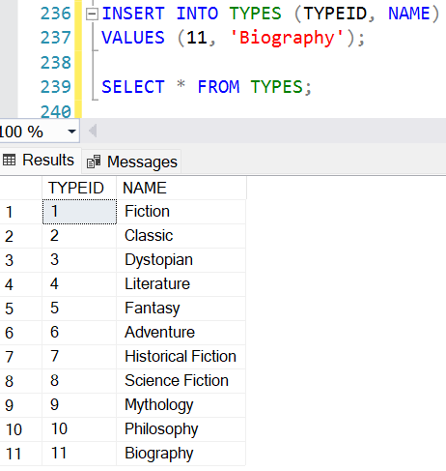

- Add 10Math Class male named Thomas Nelson , 9Bio class female named Sally Allen and 11His Class female named Linda Sandra in one question
Ans: INSERT INTO STUDENTS (STUDENTID, NAME, SURNAME, BIRTHDATE, GENDER, CLASS, POINT)
VALUES(11, 'Thomas', 'Nelson', '2006-05-10', 'M', '10Math', 85),
(12, 'Sally', 'Allen', '2007-08-15', 'F', '9Bio', 90),
(13, 'Linda', 'Sandra', '2005-12-20', 'F', '11His', 87);
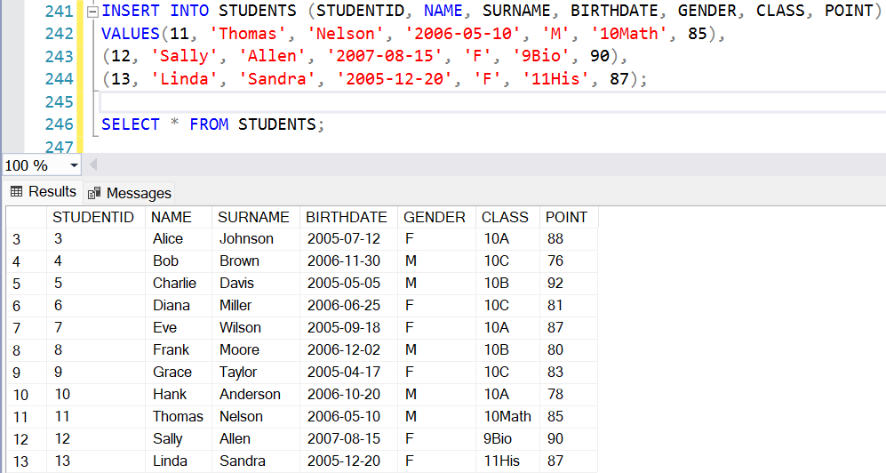

- Add a random student in the students chart to the writers chart as an authors
Ans: INSERT INTO AUTHORS (AUTHORID, NAME, SURNAME)
SELECT (SELECT ISNULL(MAX(AUTHORID), 0) + 1 FROM AUTHORS), NAME, SURNAME
FROM (SELECT TOP 1 NAME, SURNAME
FROM STUDENTS
ORDER BY NEWID()) AS RANDOMSTUDENT;
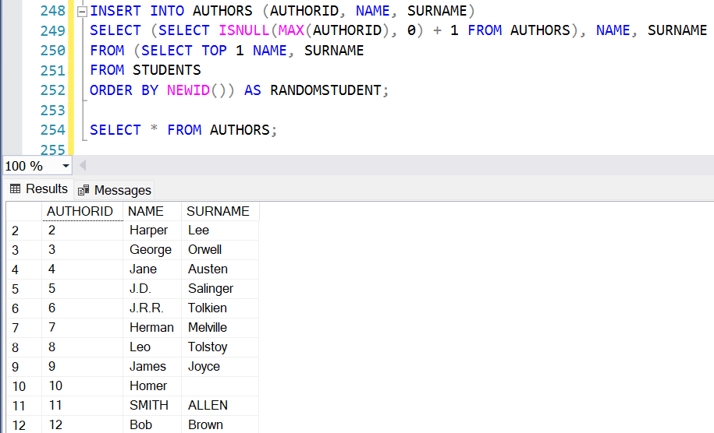

- Add students with student numbers between 10 and 30 as authors
Ans: INSERT INTO AUTHORS (AUTHORID, NAME, SURNAME)
SELECT ROW_NUMBER() OVER (ORDER BY STUDENTID)
+ (SELECT ISNULL(MAX(AUTHORID),0) FROM AUTHORS) AS NEW_AUTHORID, NAME, SURNAME
FROM STUDENTS
WHERE STUDENTID BETWEEN 10 AND 30;
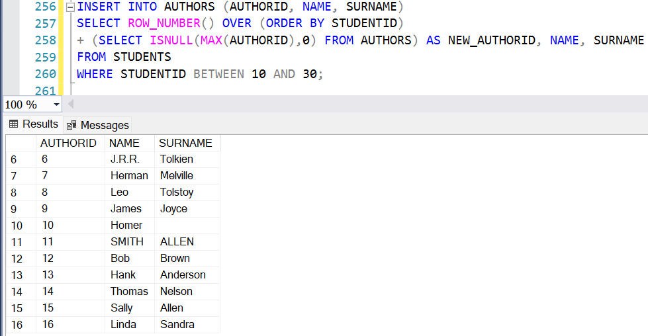

- Add the writer named Cindy Brown and make him write his writer number (Note: The last increased rate in automatic enhancing is hold in @@IDENTITY factor)
Ans: DECLARE @NEWAUTHORID INT;

INSERT INTO AUTHORS (AUTHORID, NAME, SURNAME)
VALUES ((SELECT ISNULL(MAX(AUTHORID),0) + 1 FROM AUTHORS), 'Cindy', 'Brown');

SET @NEWAUTHORID = (SELECT MAX(AUTHORID) FROM AUTHORS);

SELECT CONCAT(NAME, ' ', SURNAME, ' (', AUTHORID, ')') AS WRITERWITHID
FROM AUTHORS
WHERE AUTHORID = @NEWAUTHORID;
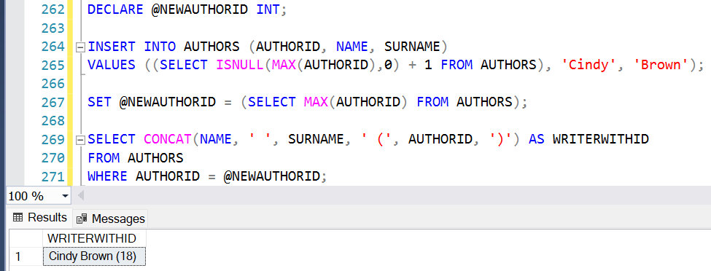

- Change the class of the student whose school number is 3 from 10Bio to 10His
Ans: UPDATE STUDENTS
SET CLASS = '10HIS'
WHERE STUDENTID = 3
AND CLASS = '10BIO';

SELECT STUDENTID, NAME, SURNAME, CLASS
FROM STUDENTS
WHERE STUDENTID = 3;
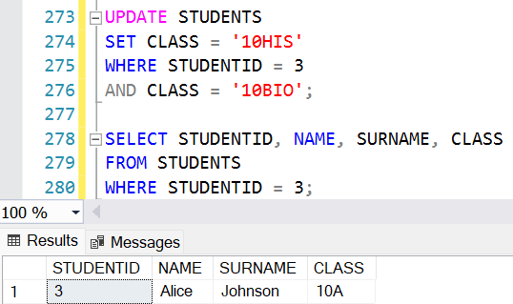

- Transfer all the students in 9Math Class to 10Math Class
Ans: UPDATE STUDENTS
SET CLASS = '10MATH'
WHERE CLASS = '9MATH'

SELECT STUDENTID, NAME, SURNAME, CLASS
FROM STUDENTS
WHERE CLASS = '10MATH';
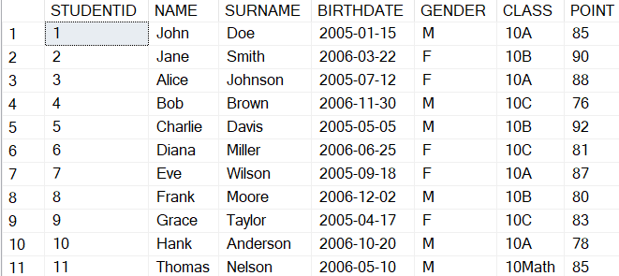
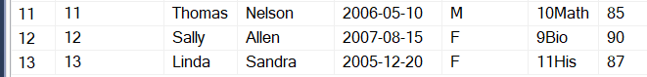

- Increase all of the students’ score by 5 points
Ans: ALTER TABLE STUDENTS
ADD POINT_PLUS5 INT;

UPDATE STUDENTS
SET POINT_PLUS5 = POINT + 5;
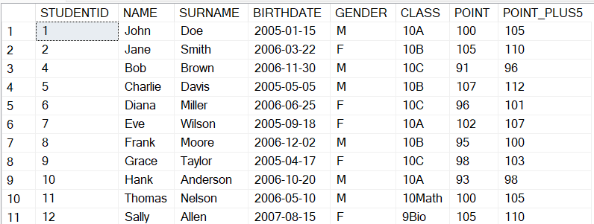

- Delete the author #25
Ans: DELETE FROM AUTHORS
WHERE AUTHORID = 25;
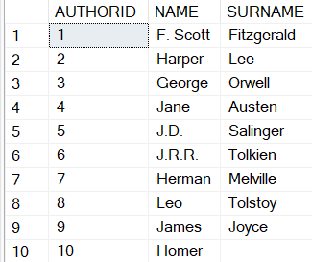
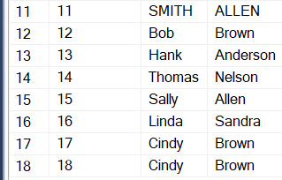

- List the students whose birth dates are null
Ans: SELECT COUNT(*) AS NULLBIRTHDATECOUNT
FROM STUDENTS
WHERE BIRTHDATE IS NULL;
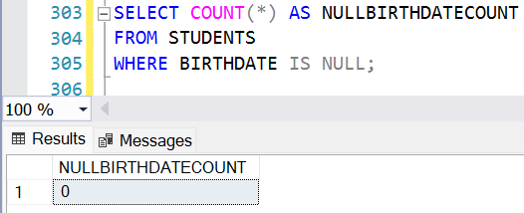

- List the name, surname and the dates of received books of the student
Ans: SELECT S.NAME, S.SURNAME, B.TAKENDATE
FROM STUDENTS S
LEFT JOIN BORROWS B ON S.STUDENTID = B.STUDENTID;
